TAHSEEN ALAM

INTERNSHIP

DAY 4 TASK 4

1.Listing all the firewall rules in windows powershell

“Get-NetFirewallRule”

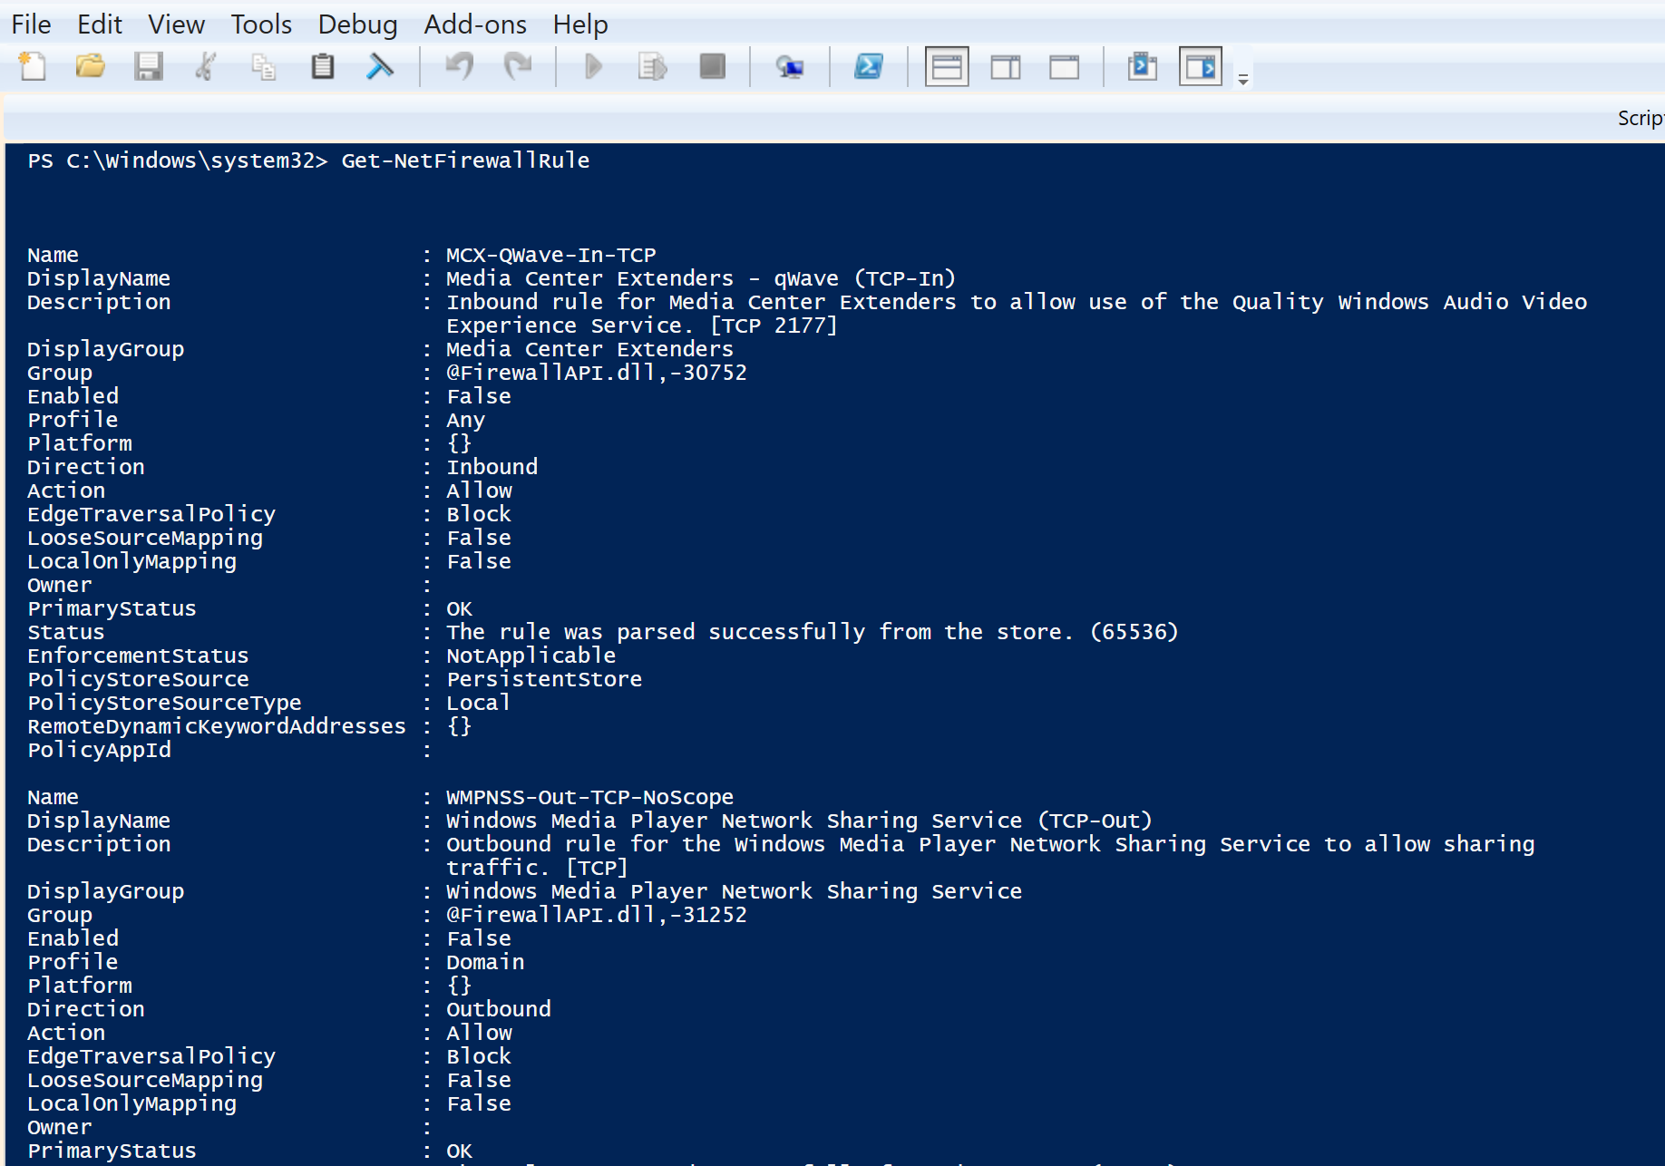

2. adding a rule to block telnet port 23

“New-NetFirewallRule -DisplayName "Block Telnet Port 23" -Direction Inbound -LocalPort 23 -Protocol TCP -Action Block”

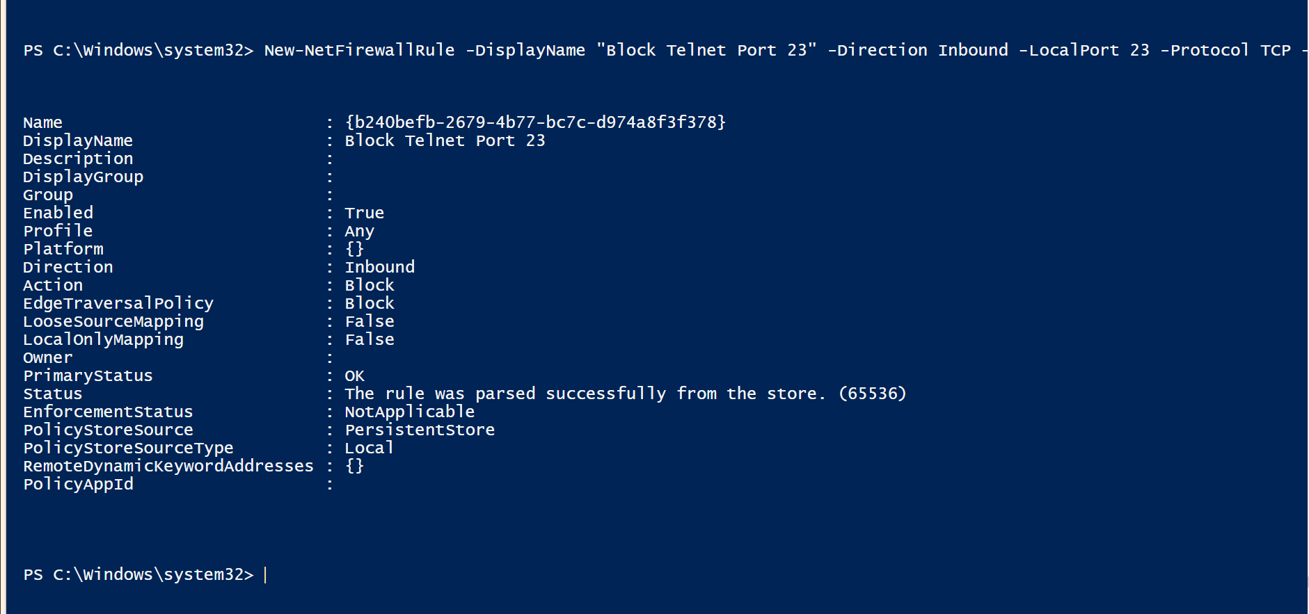

3. Testing the inbound traffic now

“Test-NetConnection -ComputerName 127.0.0.1 -Port 23”

TcpTestSucceeded: False

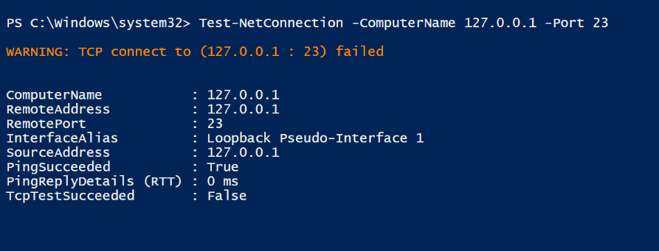

We can see TcpTestSucceeded status is False

It clearly defines that port 23 is blocked  
4. Now we will remove the added block rule to regain the status

“Remove-NetFirewallRule -DisplayName "Block Telnet Port 23" “



5. Once we remove, we will verify if it has been removed or present yet.

“Get-NetFirewallRule -DisplayName "*Telnet*" “



**SUMMARY**

The firewall checks every attempt to send or receive data against a list of rules, and decides whether to let it through or block it based on ports, addresses, direction, and protocols.